# Week 9.2

## Jumping

* Select meshes which the AI is allowed to jump from/to
* Enable the Generate OffMeshLinks option
* Configure the JumpDistance
* Bake NavMesh

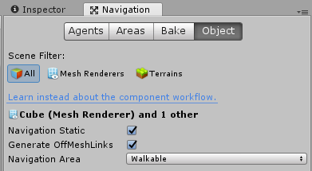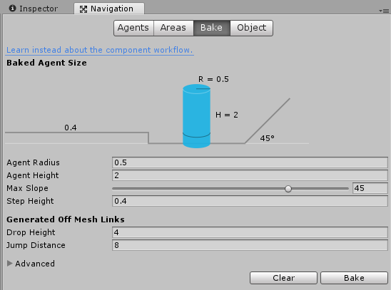

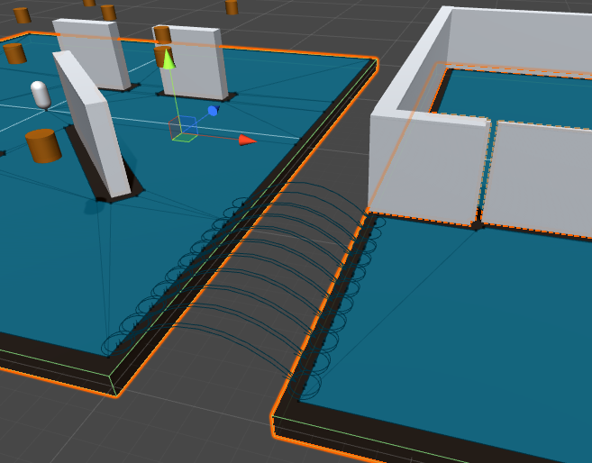

# Door

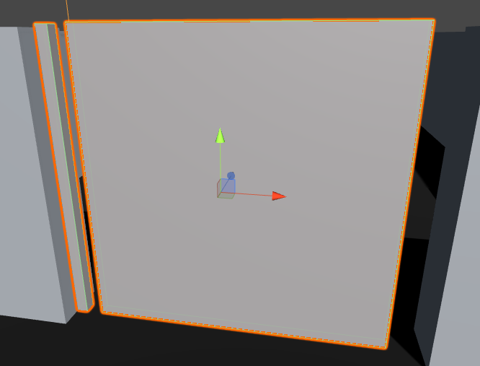

## Door Frame

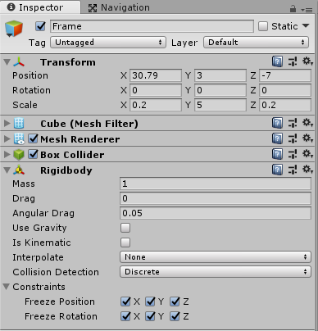

## Door

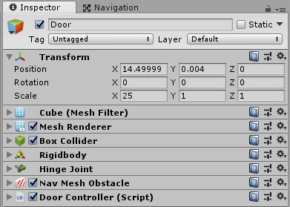

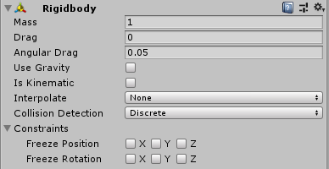

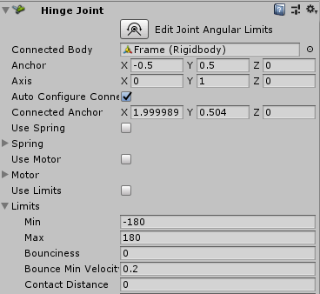

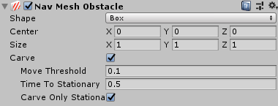



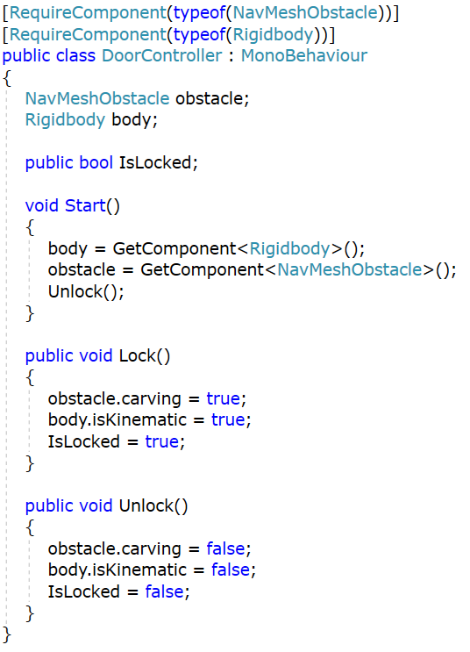

## Exercise 1: Complete AI

* Create a new script called AiController
* This Script will provide a more complete AI solution and will combine elements from previous scripts

### States

* The AI will need an Enum for the possible states it can be in. These states are
  + Patrolling
  + MovingToTarget
  + Attacking
* When the AI is in the patrolling state it should continuously move on a fixed path defined by PathMarkers
* When the AI is in the MovingToTarget state it should move within attack range of an enemy
* When the AI is in the attacking state it should “Attack” an enemy until the enemy or the AI is dead.